Proposal: New Time Clock

Adam Harris, Joshua Jolley, Andrew Rindfleisch, John Decker

# 

# 

# 

Table of Contents

[1 Executive Summary](https://docs.google.com/macros/d/M9QX-fXCODQ1HtIMXV-YoD_yoJqp5mhx5/htmlAppPanel?eei=ACZUsOeYgY2bmccI6uVxNiryGVDMu4_9cxzDnT8nSZxj4SBI4xO-abSbjSoqtsJH-1SA5bmLEkS6auyH5AFb9_0iic4n7CD79tyT32fnqOenNimQeGD-WVP7cj1lkU2cIrI8p-5qT7TQuRIHlWSW49aySEaD4JWADK2bkymfEUVBciZ7-GxCFYc&mid=ACjPJvHuRRlcijBcE8usVAP0OjHEbiKQp-L73TVzNltKkRF95UDy3KYdLWAan9dn34CaL2K0hQv1V06sm4-ZvaWg2PmxGnX2ZORNkInIrA05E-yu7IIzJp5EUC3czBIfOFeIEx0KB5NbgNY#-caja-guest-0___)

[2 Introduction](https://docs.google.com/macros/d/M9QX-fXCODQ1HtIMXV-YoD_yoJqp5mhx5/htmlAppPanel?eei=ACZUsOeYgY2bmccI6uVxNiryGVDMu4_9cxzDnT8nSZxj4SBI4xO-abSbjSoqtsJH-1SA5bmLEkS6auyH5AFb9_0iic4n7CD79tyT32fnqOenNimQeGD-WVP7cj1lkU2cIrI8p-5qT7TQuRIHlWSW49aySEaD4JWADK2bkymfEUVBciZ7-GxCFYc&mid=ACjPJvHuRRlcijBcE8usVAP0OjHEbiKQp-L73TVzNltKkRF95UDy3KYdLWAan9dn34CaL2K0hQv1V06sm4-ZvaWg2PmxGnX2ZORNkInIrA05E-yu7IIzJp5EUC3czBIfOFeIEx0KB5NbgNY#-caja-guest-0___)

[2.1 Purpose of the Proposal](https://docs.google.com/macros/d/M9QX-fXCODQ1HtIMXV-YoD_yoJqp5mhx5/htmlAppPanel?eei=ACZUsOeYgY2bmccI6uVxNiryGVDMu4_9cxzDnT8nSZxj4SBI4xO-abSbjSoqtsJH-1SA5bmLEkS6auyH5AFb9_0iic4n7CD79tyT32fnqOenNimQeGD-WVP7cj1lkU2cIrI8p-5qT7TQuRIHlWSW49aySEaD4JWADK2bkymfEUVBciZ7-GxCFYc&mid=ACjPJvHuRRlcijBcE8usVAP0OjHEbiKQp-L73TVzNltKkRF95UDy3KYdLWAan9dn34CaL2K0hQv1V06sm4-ZvaWg2PmxGnX2ZORNkInIrA05E-yu7IIzJp5EUC3czBIfOFeIEx0KB5NbgNY#-caja-guest-0___)

[2.1.1 Problem Statement](https://docs.google.com/macros/d/M9QX-fXCODQ1HtIMXV-YoD_yoJqp5mhx5/htmlAppPanel?eei=ACZUsOeYgY2bmccI6uVxNiryGVDMu4_9cxzDnT8nSZxj4SBI4xO-abSbjSoqtsJH-1SA5bmLEkS6auyH5AFb9_0iic4n7CD79tyT32fnqOenNimQeGD-WVP7cj1lkU2cIrI8p-5qT7TQuRIHlWSW49aySEaD4JWADK2bkymfEUVBciZ7-GxCFYc&mid=ACjPJvHuRRlcijBcE8usVAP0OjHEbiKQp-L73TVzNltKkRF95UDy3KYdLWAan9dn34CaL2K0hQv1V06sm4-ZvaWg2PmxGnX2ZORNkInIrA05E-yu7IIzJp5EUC3czBIfOFeIEx0KB5NbgNY#-caja-guest-0___)

[2.1.2 Objectives](https://docs.google.com/macros/d/M9QX-fXCODQ1HtIMXV-YoD_yoJqp5mhx5/htmlAppPanel?eei=ACZUsOeYgY2bmccI6uVxNiryGVDMu4_9cxzDnT8nSZxj4SBI4xO-abSbjSoqtsJH-1SA5bmLEkS6auyH5AFb9_0iic4n7CD79tyT32fnqOenNimQeGD-WVP7cj1lkU2cIrI8p-5qT7TQuRIHlWSW49aySEaD4JWADK2bkymfEUVBciZ7-GxCFYc&mid=ACjPJvHuRRlcijBcE8usVAP0OjHEbiKQp-L73TVzNltKkRF95UDy3KYdLWAan9dn34CaL2K0hQv1V06sm4-ZvaWg2PmxGnX2ZORNkInIrA05E-yu7IIzJp5EUC3czBIfOFeIEx0KB5NbgNY#-caja-guest-0___)

[2.2 Relevance to Audience](https://docs.google.com/macros/d/M9QX-fXCODQ1HtIMXV-YoD_yoJqp5mhx5/htmlAppPanel?eei=ACZUsOeYgY2bmccI6uVxNiryGVDMu4_9cxzDnT8nSZxj4SBI4xO-abSbjSoqtsJH-1SA5bmLEkS6auyH5AFb9_0iic4n7CD79tyT32fnqOenNimQeGD-WVP7cj1lkU2cIrI8p-5qT7TQuRIHlWSW49aySEaD4JWADK2bkymfEUVBciZ7-GxCFYc&mid=ACjPJvHuRRlcijBcE8usVAP0OjHEbiKQp-L73TVzNltKkRF95UDy3KYdLWAan9dn34CaL2K0hQv1V06sm4-ZvaWg2PmxGnX2ZORNkInIrA05E-yu7IIzJp5EUC3czBIfOFeIEx0KB5NbgNY#-caja-guest-0___)

[2.3 Credibility of performing organization](https://docs.google.com/macros/d/M9QX-fXCODQ1HtIMXV-YoD_yoJqp5mhx5/htmlAppPanel?eei=ACZUsOeYgY2bmccI6uVxNiryGVDMu4_9cxzDnT8nSZxj4SBI4xO-abSbjSoqtsJH-1SA5bmLEkS6auyH5AFb9_0iic4n7CD79tyT32fnqOenNimQeGD-WVP7cj1lkU2cIrI8p-5qT7TQuRIHlWSW49aySEaD4JWADK2bkymfEUVBciZ7-GxCFYc&mid=ACjPJvHuRRlcijBcE8usVAP0OjHEbiKQp-L73TVzNltKkRF95UDy3KYdLWAan9dn34CaL2K0hQv1V06sm4-ZvaWg2PmxGnX2ZORNkInIrA05E-yu7IIzJp5EUC3czBIfOFeIEx0KB5NbgNY#-caja-guest-0___)

[2.4 Proposal Organization](https://docs.google.com/macros/d/M9QX-fXCODQ1HtIMXV-YoD_yoJqp5mhx5/htmlAppPanel?eei=ACZUsOeYgY2bmccI6uVxNiryGVDMu4_9cxzDnT8nSZxj4SBI4xO-abSbjSoqtsJH-1SA5bmLEkS6auyH5AFb9_0iic4n7CD79tyT32fnqOenNimQeGD-WVP7cj1lkU2cIrI8p-5qT7TQuRIHlWSW49aySEaD4JWADK2bkymfEUVBciZ7-GxCFYc&mid=ACjPJvHuRRlcijBcE8usVAP0OjHEbiKQp-L73TVzNltKkRF95UDy3KYdLWAan9dn34CaL2K0hQv1V06sm4-ZvaWg2PmxGnX2ZORNkInIrA05E-yu7IIzJp5EUC3czBIfOFeIEx0KB5NbgNY#-caja-guest-0___)

[3 Problem Statement](https://docs.google.com/macros/d/M9QX-fXCODQ1HtIMXV-YoD_yoJqp5mhx5/htmlAppPanel?eei=ACZUsOeYgY2bmccI6uVxNiryGVDMu4_9cxzDnT8nSZxj4SBI4xO-abSbjSoqtsJH-1SA5bmLEkS6auyH5AFb9_0iic4n7CD79tyT32fnqOenNimQeGD-WVP7cj1lkU2cIrI8p-5qT7TQuRIHlWSW49aySEaD4JWADK2bkymfEUVBciZ7-GxCFYc&mid=ACjPJvHuRRlcijBcE8usVAP0OjHEbiKQp-L73TVzNltKkRF95UDy3KYdLWAan9dn34CaL2K0hQv1V06sm4-ZvaWg2PmxGnX2ZORNkInIrA05E-yu7IIzJp5EUC3czBIfOFeIEx0KB5NbgNY#-caja-guest-0___)

[3.1 Reason for the Proposed Project](https://docs.google.com/macros/d/M9QX-fXCODQ1HtIMXV-YoD_yoJqp5mhx5/htmlAppPanel?eei=ACZUsOeYgY2bmccI6uVxNiryGVDMu4_9cxzDnT8nSZxj4SBI4xO-abSbjSoqtsJH-1SA5bmLEkS6auyH5AFb9_0iic4n7CD79tyT32fnqOenNimQeGD-WVP7cj1lkU2cIrI8p-5qT7TQuRIHlWSW49aySEaD4JWADK2bkymfEUVBciZ7-GxCFYc&mid=ACjPJvHuRRlcijBcE8usVAP0OjHEbiKQp-L73TVzNltKkRF95UDy3KYdLWAan9dn34CaL2K0hQv1V06sm4-ZvaWg2PmxGnX2ZORNkInIrA05E-yu7IIzJp5EUC3czBIfOFeIEx0KB5NbgNY#-caja-guest-0___)

[3.2 Problem Explanation](https://docs.google.com/macros/d/M9QX-fXCODQ1HtIMXV-YoD_yoJqp5mhx5/htmlAppPanel?eei=ACZUsOeYgY2bmccI6uVxNiryGVDMu4_9cxzDnT8nSZxj4SBI4xO-abSbjSoqtsJH-1SA5bmLEkS6auyH5AFb9_0iic4n7CD79tyT32fnqOenNimQeGD-WVP7cj1lkU2cIrI8p-5qT7TQuRIHlWSW49aySEaD4JWADK2bkymfEUVBciZ7-GxCFYc&mid=ACjPJvHuRRlcijBcE8usVAP0OjHEbiKQp-L73TVzNltKkRF95UDy3KYdLWAan9dn34CaL2K0hQv1V06sm4-ZvaWg2PmxGnX2ZORNkInIrA05E-yu7IIzJp5EUC3czBIfOFeIEx0KB5NbgNY#-caja-guest-0___)

[4 Objective](https://docs.google.com/macros/d/M9QX-fXCODQ1HtIMXV-YoD_yoJqp5mhx5/htmlAppPanel?eei=ACZUsOeYgY2bmccI6uVxNiryGVDMu4_9cxzDnT8nSZxj4SBI4xO-abSbjSoqtsJH-1SA5bmLEkS6auyH5AFb9_0iic4n7CD79tyT32fnqOenNimQeGD-WVP7cj1lkU2cIrI8p-5qT7TQuRIHlWSW49aySEaD4JWADK2bkymfEUVBciZ7-GxCFYc&mid=ACjPJvHuRRlcijBcE8usVAP0OjHEbiKQp-L73TVzNltKkRF95UDy3KYdLWAan9dn34CaL2K0hQv1V06sm4-ZvaWg2PmxGnX2ZORNkInIrA05E-yu7IIzJp5EUC3czBIfOFeIEx0KB5NbgNY#-caja-guest-0___)

[5 Plan](https://docs.google.com/macros/d/M9QX-fXCODQ1HtIMXV-YoD_yoJqp5mhx5/htmlAppPanel?eei=ACZUsOeYgY2bmccI6uVxNiryGVDMu4_9cxzDnT8nSZxj4SBI4xO-abSbjSoqtsJH-1SA5bmLEkS6auyH5AFb9_0iic4n7CD79tyT32fnqOenNimQeGD-WVP7cj1lkU2cIrI8p-5qT7TQuRIHlWSW49aySEaD4JWADK2bkymfEUVBciZ7-GxCFYc&mid=ACjPJvHuRRlcijBcE8usVAP0OjHEbiKQp-L73TVzNltKkRF95UDy3KYdLWAan9dn34CaL2K0hQv1V06sm4-ZvaWg2PmxGnX2ZORNkInIrA05E-yu7IIzJp5EUC3czBIfOFeIEx0KB5NbgNY#-caja-guest-0___)

[5.1 Tasks](https://docs.google.com/macros/d/M9QX-fXCODQ1HtIMXV-YoD_yoJqp5mhx5/htmlAppPanel?eei=ACZUsOeYgY2bmccI6uVxNiryGVDMu4_9cxzDnT8nSZxj4SBI4xO-abSbjSoqtsJH-1SA5bmLEkS6auyH5AFb9_0iic4n7CD79tyT32fnqOenNimQeGD-WVP7cj1lkU2cIrI8p-5qT7TQuRIHlWSW49aySEaD4JWADK2bkymfEUVBciZ7-GxCFYc&mid=ACjPJvHuRRlcijBcE8usVAP0OjHEbiKQp-L73TVzNltKkRF95UDy3KYdLWAan9dn34CaL2K0hQv1V06sm4-ZvaWg2PmxGnX2ZORNkInIrA05E-yu7IIzJp5EUC3czBIfOFeIEx0KB5NbgNY#-caja-guest-0___)

[5.2 Schedule](https://docs.google.com/macros/d/M9QX-fXCODQ1HtIMXV-YoD_yoJqp5mhx5/htmlAppPanel?eei=ACZUsOeYgY2bmccI6uVxNiryGVDMu4_9cxzDnT8nSZxj4SBI4xO-abSbjSoqtsJH-1SA5bmLEkS6auyH5AFb9_0iic4n7CD79tyT32fnqOenNimQeGD-WVP7cj1lkU2cIrI8p-5qT7TQuRIHlWSW49aySEaD4JWADK2bkymfEUVBciZ7-GxCFYc&mid=ACjPJvHuRRlcijBcE8usVAP0OjHEbiKQp-L73TVzNltKkRF95UDy3KYdLWAan9dn34CaL2K0hQv1V06sm4-ZvaWg2PmxGnX2ZORNkInIrA05E-yu7IIzJp5EUC3czBIfOFeIEx0KB5NbgNY#-caja-guest-0___)

[5.3 Location](https://docs.google.com/macros/d/M9QX-fXCODQ1HtIMXV-YoD_yoJqp5mhx5/htmlAppPanel?eei=ACZUsOeYgY2bmccI6uVxNiryGVDMu4_9cxzDnT8nSZxj4SBI4xO-abSbjSoqtsJH-1SA5bmLEkS6auyH5AFb9_0iic4n7CD79tyT32fnqOenNimQeGD-WVP7cj1lkU2cIrI8p-5qT7TQuRIHlWSW49aySEaD4JWADK2bkymfEUVBciZ7-GxCFYc&mid=ACjPJvHuRRlcijBcE8usVAP0OjHEbiKQp-L73TVzNltKkRF95UDy3KYdLWAan9dn34CaL2K0hQv1V06sm4-ZvaWg2PmxGnX2ZORNkInIrA05E-yu7IIzJp5EUC3czBIfOFeIEx0KB5NbgNY#-caja-guest-0___)

[5.4 Personnel](https://docs.google.com/macros/d/M9QX-fXCODQ1HtIMXV-YoD_yoJqp5mhx5/htmlAppPanel?eei=ACZUsOeYgY2bmccI6uVxNiryGVDMu4_9cxzDnT8nSZxj4SBI4xO-abSbjSoqtsJH-1SA5bmLEkS6auyH5AFb9_0iic4n7CD79tyT32fnqOenNimQeGD-WVP7cj1lkU2cIrI8p-5qT7TQuRIHlWSW49aySEaD4JWADK2bkymfEUVBciZ7-GxCFYc&mid=ACjPJvHuRRlcijBcE8usVAP0OjHEbiKQp-L73TVzNltKkRF95UDy3KYdLWAan9dn34CaL2K0hQv1V06sm4-ZvaWg2PmxGnX2ZORNkInIrA05E-yu7IIzJp5EUC3czBIfOFeIEx0KB5NbgNY#-caja-guest-0___)

[5.5 Progress Reports](https://docs.google.com/macros/d/M9QX-fXCODQ1HtIMXV-YoD_yoJqp5mhx5/htmlAppPanel?eei=ACZUsOeYgY2bmccI6uVxNiryGVDMu4_9cxzDnT8nSZxj4SBI4xO-abSbjSoqtsJH-1SA5bmLEkS6auyH5AFb9_0iic4n7CD79tyT32fnqOenNimQeGD-WVP7cj1lkU2cIrI8p-5qT7TQuRIHlWSW49aySEaD4JWADK2bkymfEUVBciZ7-GxCFYc&mid=ACjPJvHuRRlcijBcE8usVAP0OjHEbiKQp-L73TVzNltKkRF95UDy3KYdLWAan9dn34CaL2K0hQv1V06sm4-ZvaWg2PmxGnX2ZORNkInIrA05E-yu7IIzJp5EUC3czBIfOFeIEx0KB5NbgNY#-caja-guest-0___)

[6 Budget](https://docs.google.com/macros/d/M9QX-fXCODQ1HtIMXV-YoD_yoJqp5mhx5/htmlAppPanel?eei=ACZUsOeYgY2bmccI6uVxNiryGVDMu4_9cxzDnT8nSZxj4SBI4xO-abSbjSoqtsJH-1SA5bmLEkS6auyH5AFb9_0iic4n7CD79tyT32fnqOenNimQeGD-WVP7cj1lkU2cIrI8p-5qT7TQuRIHlWSW49aySEaD4JWADK2bkymfEUVBciZ7-GxCFYc&mid=ACjPJvHuRRlcijBcE8usVAP0OjHEbiKQp-L73TVzNltKkRF95UDy3KYdLWAan9dn34CaL2K0hQv1V06sm4-ZvaWg2PmxGnX2ZORNkInIrA05E-yu7IIzJp5EUC3czBIfOFeIEx0KB5NbgNY#-caja-guest-0___)

[6.1 Cost Breakdown](https://docs.google.com/macros/d/M9QX-fXCODQ1HtIMXV-YoD_yoJqp5mhx5/htmlAppPanel?eei=ACZUsOeYgY2bmccI6uVxNiryGVDMu4_9cxzDnT8nSZxj4SBI4xO-abSbjSoqtsJH-1SA5bmLEkS6auyH5AFb9_0iic4n7CD79tyT32fnqOenNimQeGD-WVP7cj1lkU2cIrI8p-5qT7TQuRIHlWSW49aySEaD4JWADK2bkymfEUVBciZ7-GxCFYc&mid=ACjPJvHuRRlcijBcE8usVAP0OjHEbiKQp-L73TVzNltKkRF95UDy3KYdLWAan9dn34CaL2K0hQv1V06sm4-ZvaWg2PmxGnX2ZORNkInIrA05E-yu7IIzJp5EUC3czBIfOFeIEx0KB5NbgNY#-caja-guest-0___)

[6.1.1 Automated Schedule](https://docs.google.com/macros/d/M9QX-fXCODQ1HtIMXV-YoD_yoJqp5mhx5/htmlAppPanel?eei=ACZUsOeYgY2bmccI6uVxNiryGVDMu4_9cxzDnT8nSZxj4SBI4xO-abSbjSoqtsJH-1SA5bmLEkS6auyH5AFb9_0iic4n7CD79tyT32fnqOenNimQeGD-WVP7cj1lkU2cIrI8p-5qT7TQuRIHlWSW49aySEaD4JWADK2bkymfEUVBciZ7-GxCFYc&mid=ACjPJvHuRRlcijBcE8usVAP0OjHEbiKQp-L73TVzNltKkRF95UDy3KYdLWAan9dn34CaL2K0hQv1V06sm4-ZvaWg2PmxGnX2ZORNkInIrA05E-yu7IIzJp5EUC3czBIfOFeIEx0KB5NbgNY#-caja-guest-0___)

[6.1.2 User-interface Update](https://docs.google.com/macros/d/M9QX-fXCODQ1HtIMXV-YoD_yoJqp5mhx5/htmlAppPanel?eei=ACZUsOeYgY2bmccI6uVxNiryGVDMu4_9cxzDnT8nSZxj4SBI4xO-abSbjSoqtsJH-1SA5bmLEkS6auyH5AFb9_0iic4n7CD79tyT32fnqOenNimQeGD-WVP7cj1lkU2cIrI8p-5qT7TQuRIHlWSW49aySEaD4JWADK2bkymfEUVBciZ7-GxCFYc&mid=ACjPJvHuRRlcijBcE8usVAP0OjHEbiKQp-L73TVzNltKkRF95UDy3KYdLWAan9dn34CaL2K0hQv1V06sm4-ZvaWg2PmxGnX2ZORNkInIrA05E-yu7IIzJp5EUC3czBIfOFeIEx0KB5NbgNY#-caja-guest-0___)

[6.2 Bottom Line](https://docs.google.com/macros/d/M9QX-fXCODQ1HtIMXV-YoD_yoJqp5mhx5/htmlAppPanel?eei=ACZUsOeYgY2bmccI6uVxNiryGVDMu4_9cxzDnT8nSZxj4SBI4xO-abSbjSoqtsJH-1SA5bmLEkS6auyH5AFb9_0iic4n7CD79tyT32fnqOenNimQeGD-WVP7cj1lkU2cIrI8p-5qT7TQuRIHlWSW49aySEaD4JWADK2bkymfEUVBciZ7-GxCFYc&mid=ACjPJvHuRRlcijBcE8usVAP0OjHEbiKQp-L73TVzNltKkRF95UDy3KYdLWAan9dn34CaL2K0hQv1V06sm4-ZvaWg2PmxGnX2ZORNkInIrA05E-yu7IIzJp5EUC3czBIfOFeIEx0KB5NbgNY#-caja-guest-0___)

[6.3 Return on Investment](https://docs.google.com/macros/d/M9QX-fXCODQ1HtIMXV-YoD_yoJqp5mhx5/htmlAppPanel?eei=ACZUsOeYgY2bmccI6uVxNiryGVDMu4_9cxzDnT8nSZxj4SBI4xO-abSbjSoqtsJH-1SA5bmLEkS6auyH5AFb9_0iic4n7CD79tyT32fnqOenNimQeGD-WVP7cj1lkU2cIrI8p-5qT7TQuRIHlWSW49aySEaD4JWADK2bkymfEUVBciZ7-GxCFYc&mid=ACjPJvHuRRlcijBcE8usVAP0OjHEbiKQp-L73TVzNltKkRF95UDy3KYdLWAan9dn34CaL2K0hQv1V06sm4-ZvaWg2PmxGnX2ZORNkInIrA05E-yu7IIzJp5EUC3czBIfOFeIEx0KB5NbgNY#-caja-guest-0___)

[7 Personnel and Qualifications](https://docs.google.com/macros/d/M9QX-fXCODQ1HtIMXV-YoD_yoJqp5mhx5/htmlAppPanel?eei=ACZUsOeYgY2bmccI6uVxNiryGVDMu4_9cxzDnT8nSZxj4SBI4xO-abSbjSoqtsJH-1SA5bmLEkS6auyH5AFb9_0iic4n7CD79tyT32fnqOenNimQeGD-WVP7cj1lkU2cIrI8p-5qT7TQuRIHlWSW49aySEaD4JWADK2bkymfEUVBciZ7-GxCFYc&mid=ACjPJvHuRRlcijBcE8usVAP0OjHEbiKQp-L73TVzNltKkRF95UDy3KYdLWAan9dn34CaL2K0hQv1V06sm4-ZvaWg2PmxGnX2ZORNkInIrA05E-yu7IIzJp5EUC3czBIfOFeIEx0KB5NbgNY#-caja-guest-0___)

[7.1 Adam Harris - Program Manager](https://docs.google.com/macros/d/M9QX-fXCODQ1HtIMXV-YoD_yoJqp5mhx5/htmlAppPanel?eei=ACZUsOeYgY2bmccI6uVxNiryGVDMu4_9cxzDnT8nSZxj4SBI4xO-abSbjSoqtsJH-1SA5bmLEkS6auyH5AFb9_0iic4n7CD79tyT32fnqOenNimQeGD-WVP7cj1lkU2cIrI8p-5qT7TQuRIHlWSW49aySEaD4JWADK2bkymfEUVBciZ7-GxCFYc&mid=ACjPJvHuRRlcijBcE8usVAP0OjHEbiKQp-L73TVzNltKkRF95UDy3KYdLWAan9dn34CaL2K0hQv1V06sm4-ZvaWg2PmxGnX2ZORNkInIrA05E-yu7IIzJp5EUC3czBIfOFeIEx0KB5NbgNY#-caja-guest-0___)

[7.2 John Decker - Interface Architect](https://docs.google.com/macros/d/M9QX-fXCODQ1HtIMXV-YoD_yoJqp5mhx5/htmlAppPanel?eei=ACZUsOeYgY2bmccI6uVxNiryGVDMu4_9cxzDnT8nSZxj4SBI4xO-abSbjSoqtsJH-1SA5bmLEkS6auyH5AFb9_0iic4n7CD79tyT32fnqOenNimQeGD-WVP7cj1lkU2cIrI8p-5qT7TQuRIHlWSW49aySEaD4JWADK2bkymfEUVBciZ7-GxCFYc&mid=ACjPJvHuRRlcijBcE8usVAP0OjHEbiKQp-L73TVzNltKkRF95UDy3KYdLWAan9dn34CaL2K0hQv1V06sm4-ZvaWg2PmxGnX2ZORNkInIrA05E-yu7IIzJp5EUC3czBIfOFeIEx0KB5NbgNY#-caja-guest-0___)

[7.3 Joshua Jolley - Software Engineer](https://docs.google.com/macros/d/M9QX-fXCODQ1HtIMXV-YoD_yoJqp5mhx5/htmlAppPanel?eei=ACZUsOeYgY2bmccI6uVxNiryGVDMu4_9cxzDnT8nSZxj4SBI4xO-abSbjSoqtsJH-1SA5bmLEkS6auyH5AFb9_0iic4n7CD79tyT32fnqOenNimQeGD-WVP7cj1lkU2cIrI8p-5qT7TQuRIHlWSW49aySEaD4JWADK2bkymfEUVBciZ7-GxCFYc&mid=ACjPJvHuRRlcijBcE8usVAP0OjHEbiKQp-L73TVzNltKkRF95UDy3KYdLWAan9dn34CaL2K0hQv1V06sm4-ZvaWg2PmxGnX2ZORNkInIrA05E-yu7IIzJp5EUC3czBIfOFeIEx0KB5NbgNY#-caja-guest-0___)

[7.4 Andrew Rindfleisch - Software Engineer](https://docs.google.com/macros/d/M9QX-fXCODQ1HtIMXV-YoD_yoJqp5mhx5/htmlAppPanel?eei=ACZUsOeYgY2bmccI6uVxNiryGVDMu4_9cxzDnT8nSZxj4SBI4xO-abSbjSoqtsJH-1SA5bmLEkS6auyH5AFb9_0iic4n7CD79tyT32fnqOenNimQeGD-WVP7cj1lkU2cIrI8p-5qT7TQuRIHlWSW49aySEaD4JWADK2bkymfEUVBciZ7-GxCFYc&mid=ACjPJvHuRRlcijBcE8usVAP0OjHEbiKQp-L73TVzNltKkRF95UDy3KYdLWAan9dn34CaL2K0hQv1V06sm4-ZvaWg2PmxGnX2ZORNkInIrA05E-yu7IIzJp5EUC3czBIfOFeIEx0KB5NbgNY#-caja-guest-0___)

[8 Facilities and Equipment](https://docs.google.com/macros/d/M9QX-fXCODQ1HtIMXV-YoD_yoJqp5mhx5/htmlAppPanel?eei=ACZUsOeYgY2bmccI6uVxNiryGVDMu4_9cxzDnT8nSZxj4SBI4xO-abSbjSoqtsJH-1SA5bmLEkS6auyH5AFb9_0iic4n7CD79tyT32fnqOenNimQeGD-WVP7cj1lkU2cIrI8p-5qT7TQuRIHlWSW49aySEaD4JWADK2bkymfEUVBciZ7-GxCFYc&mid=ACjPJvHuRRlcijBcE8usVAP0OjHEbiKQp-L73TVzNltKkRF95UDy3KYdLWAan9dn34CaL2K0hQv1V06sm4-ZvaWg2PmxGnX2ZORNkInIrA05E-yu7IIzJp5EUC3czBIfOFeIEx0KB5NbgNY#-caja-guest-0___)

[8.1 Facilities](https://docs.google.com/macros/d/M9QX-fXCODQ1HtIMXV-YoD_yoJqp5mhx5/htmlAppPanel?eei=ACZUsOeYgY2bmccI6uVxNiryGVDMu4_9cxzDnT8nSZxj4SBI4xO-abSbjSoqtsJH-1SA5bmLEkS6auyH5AFb9_0iic4n7CD79tyT32fnqOenNimQeGD-WVP7cj1lkU2cIrI8p-5qT7TQuRIHlWSW49aySEaD4JWADK2bkymfEUVBciZ7-GxCFYc&mid=ACjPJvHuRRlcijBcE8usVAP0OjHEbiKQp-L73TVzNltKkRF95UDy3KYdLWAan9dn34CaL2K0hQv1V06sm4-ZvaWg2PmxGnX2ZORNkInIrA05E-yu7IIzJp5EUC3czBIfOFeIEx0KB5NbgNY#-caja-guest-0___)

[8.2 Equipment](https://docs.google.com/macros/d/M9QX-fXCODQ1HtIMXV-YoD_yoJqp5mhx5/htmlAppPanel?eei=ACZUsOeYgY2bmccI6uVxNiryGVDMu4_9cxzDnT8nSZxj4SBI4xO-abSbjSoqtsJH-1SA5bmLEkS6auyH5AFb9_0iic4n7CD79tyT32fnqOenNimQeGD-WVP7cj1lkU2cIrI8p-5qT7TQuRIHlWSW49aySEaD4JWADK2bkymfEUVBciZ7-GxCFYc&mid=ACjPJvHuRRlcijBcE8usVAP0OjHEbiKQp-L73TVzNltKkRF95UDy3KYdLWAan9dn34CaL2K0hQv1V06sm4-ZvaWg2PmxGnX2ZORNkInIrA05E-yu7IIzJp5EUC3czBIfOFeIEx0KB5NbgNY#-caja-guest-0___)

# 1 Executive Summary

**Problem:** The current time clock system wastes university money due to inefficiency and inaccuracy.

**Objective:** Our objective is to create and implement a more efficient and

accurate time clock system.

**Plan:** We will first design and implement an automated time clock system. Next we will design and implement a new user-interface. The project will be developed in the Austin building on the BYU-Idaho campus.

**Schedule:** We will spend 4 weeks designing and developing the automatic time clock, one week redesigning the user-interface, and one week linking and testing.

**Budget:** The entire project will cost $28,800, but has an ROI over 5 years

of 5:1.

**Personnel:** Our team has 11 years collective web development experience and 12 years collective programming experience.

**Facilities:** Our team will require a working space and access to school servers during the duration of this project.

# 

# 

# **2 Introduction**

## 2.1 Purpose of the Proposal

### 2.1.1 Problem Statement

The current time clock system wastes university money due to inaccurate time entries.

### 2.1.2 Objectives

We will save the university money by designing and implementing a time clock that is more efficient and accurate than the current system.

## 2.2 Relevance to Audience

The payroll department will save the Church’s sacred tithing funds.

## 2.3 Credibility of performing organization

Our group has 11 years of collective web development experience and 12 years of collective programming experience.

## 2.4 Proposal Organization

The following sections of the proposal are described in this paragraph:

* The problem statement explains why the proposed time clock should be implemented.
* The objectives section explains the project outcomes in specific, measurable goals.
* The plan section gives specifics about the project schedule and how we will accomplish our goals.
* The budget section describes the costs and return on investment.
* The personnel and qualifications section outlines the qualifications and experience of each team member.
* The facilities and equipment section enumerates what equipment and access we will need to complete the project.

# 

# 

# **3 Problem Statement**

## 3.1 Reason for the Proposed Project

The current time clock system (as seen in figure 1) wastes university money due to inaccurate time entries.

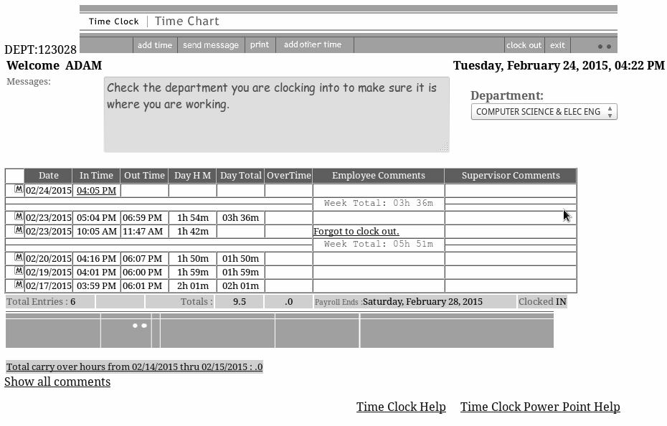

Figure 1: Current BYU-Idaho time clock interface.

Source: [*https://web.byui.edu/timeclock/TimeCardDisplay.asp*](https://web.byui.edu/timeclock/TimeCardDisplay.asp)

## 3.2 Problem Explanation

When an employee inserts their time after having completed their work they are only able to select time in ten-minute increments (see Figure 2). This results in frequent five-minute overbillings. These discrepancies add up to a loss of $34,860 per year for the university (see 6.2).

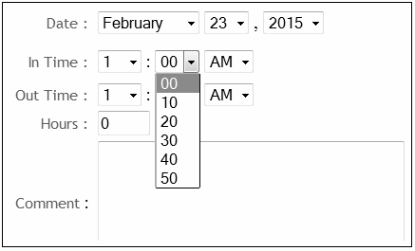

Figure 2: Entering time on the current BYU-Idaho time clock.

Source: *https://web.byui.edu/timeclock/addtime.asp?Dept=123028*

# 

# 

# 

# 

# **4 Objective**

Our main objective is to reduce the time employees spend using the time clock by at least four minutes per employee for each pay period. We seek to create and implement both a redesigned user-interface for the time clock system (see figure 3), and a system that will automatically enter time for employees based on a predetermined schedule. This new system will save the university $34,860 (see 6.2) every year after its implementation.

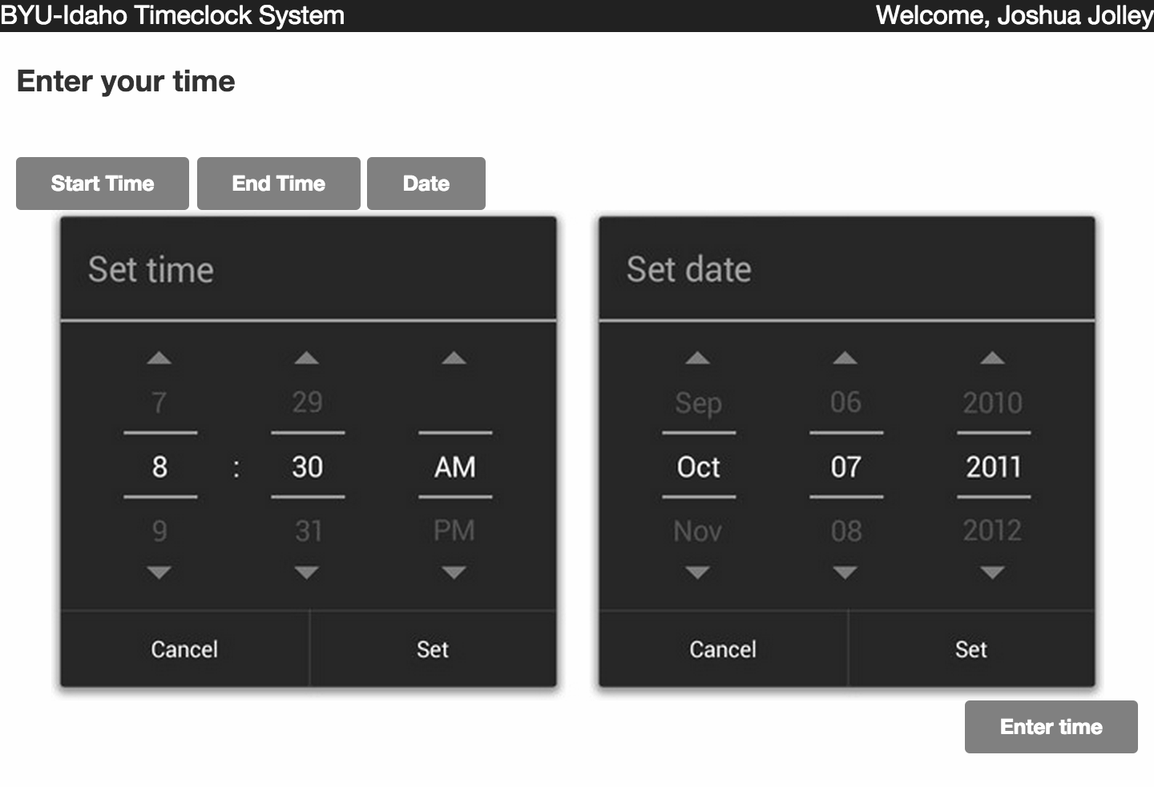

Figure 3: A prototype of the UI for the new time clock.

Source: Joshua Jolley

# 

# 

# **5 Plan**

## 5.1 Tasks

For the automated time clock, we will design, develop, and implement the system in that order. In order to follow this pattern, we will begin by creating a design that encompasses both back-end (server application development) and front-end development (user-interface).

## 5.2 Schedule

Development for the time clock will have weekly intervals of design and development. The entire project will take 6 weeks (see Figure 4).

**Week 1**

* Setup the office
* Learn how to interface with the database
* Begin design for automated time clock

**Week 2**

* Continue design for automated time clock

**Week 3**

* Begin developing on our design

**Week 4**

* Complete developing the automated time clock

**Week 5**

* Design and develop the front-end

**Week 6**

* Linking and testing

Figure 4: Gantt Chart for the automated time clock project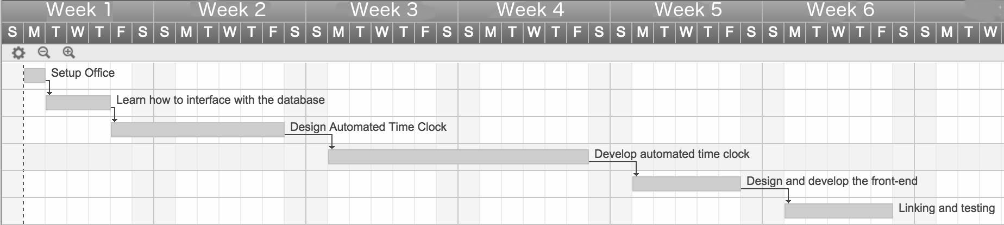

Source: John Decker

## 5**.3** **Location**

The program will be developed within the Austin building, unless otherwise requested from the payroll office.

## 5**.4** **Personnel**

This project will be completed by Adam Harris, Joshua Jolley, John Decker, and Andrew Rindfleisch. All are students studying Computer Science. We (the team) will require the assistance of a member of the IT department who is familiar with the current time clock. We will need him or her for the first day of development to familiarize ourselves with the vital parts of the system architecture that we will be using to create the new time clock.

## 5.5 Progress Reports

Progress will be reported at the end of every week will via email to the university payroll staff. Face-to-face meetings will also occur with the development team and payroll staff on an as-needed basis.

# **6 Budget**

## 6.1 Cost Breakdown

## 6.1.1 Automated Schedule

The development of an automated schedule will take our team 4 weeks to complete. With all four of us working 40 hours a week at $30 per hour, the budget for this feature is $19,200.

## 6.1.2 User-interface Update

The development of a new user-interface will take our team of four developers 2 weeks to complete. With all four of us working 40 hours a week at $30 per hour, this sets the budget for this feature at $9,600.

## 6.2 Bottom Line

The combined cost for the features we are implementing is $28,800. Our proposed solution will reduce university costs by approximately $34,860 per year by reducing the paid time spent entering student hours by four minutes per employee. The university currently employs around 3000 students with a starting pay of $8.30 an hour. Our informal poll of student employees revealed that it takes an employee five minutes to record the number of hours worked in a pay period using the current system. There are 21 pay periods in the 42 weeks of our 3 semester system. Our automated system will reduce the time from five minutes to one minute, resulting in a savings of $34,860 per year after the first year, as shown in Figure 5.

4 minutes 3000 employees $8.30 21 pay periods $34,860

------------ * --------------------- * -------- * --------------------- = ------------

employee 1 hour year year

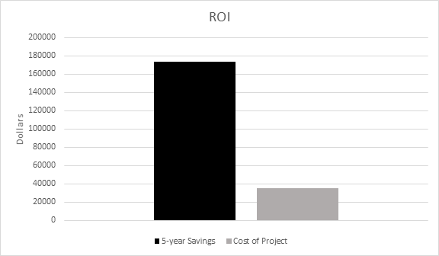

Figure 5: Cost vs. Savings

Source: Adam Harris

## 6.3 Return on Investment

This proposal pays for itself in the first year, with an additional estimated savings of $6,020. The real strength of this proposal is found over a 5-year span, providing a 5:1 return on investment.

# 

# 

# 7 Personnel and Qualifications

## 7.1 Adam Harris - Program Manager

Expected B.S. in Computer Science

Programming Experience: C++, Java, and Ruby

Web Experience: HTML5 and CSS3

Two internships with Intel Security

## 7.2 John Decker - Interface Architect

Expected B.S. in Computer Science

Programming experience: C++ and Java

Web Experience: HTML5 and CSS3

## 7.3 Joshua Jolley - Software Engineer

Expected B.S. in Computer Science

Programming experience: C++, Java, and JavaScript

Web experience: HTML5, CSS3, PHP, MYSQL, Gulp, CoffeeScript, Jade, and Stylus

## 7.4 Andrew Rindfleisch - Software Engineer

Expected B.S. in Computer Science

Programming experience: C++, Java, JavaScript, and Ruby

Web experience: HTML5, CSS3, PHP, MYSQL, and Jenkins

# 

# 

# 8 Facilities and Equipment

## 8.1 Facilities

Our team will require an on-campus working space preferably in close proximity to the university IT department. We will require desk space for the four of us to collaborate on the project.

## 8.2 Equipment

We need 4 personal computers with Windows 7 and Netbeans installed. These computers will need access to the internet, and to the time clock system..